Challenge of the week #2

Please forgive me --- Please forget me, I've got coronavirus
Edvin Tirović
Enter sandman---Enter corona
Rok Markič

You are my corona,
My scary illness,
You make me worry,
When I watch TV,
You'll never know dear
How much I’m scared of you.
Please don't take
My family away.
Mark Gradišar

CORONA SONG
Corona, Corona, Coronic'a',
Don't send me virus'a',
It may happen or may not
but all I want,
to tell you my thought.

I am happy to be healthy,
and I beg you to be lazy,
you can cross my name,
and leave my family safe.
Jaka Prestor

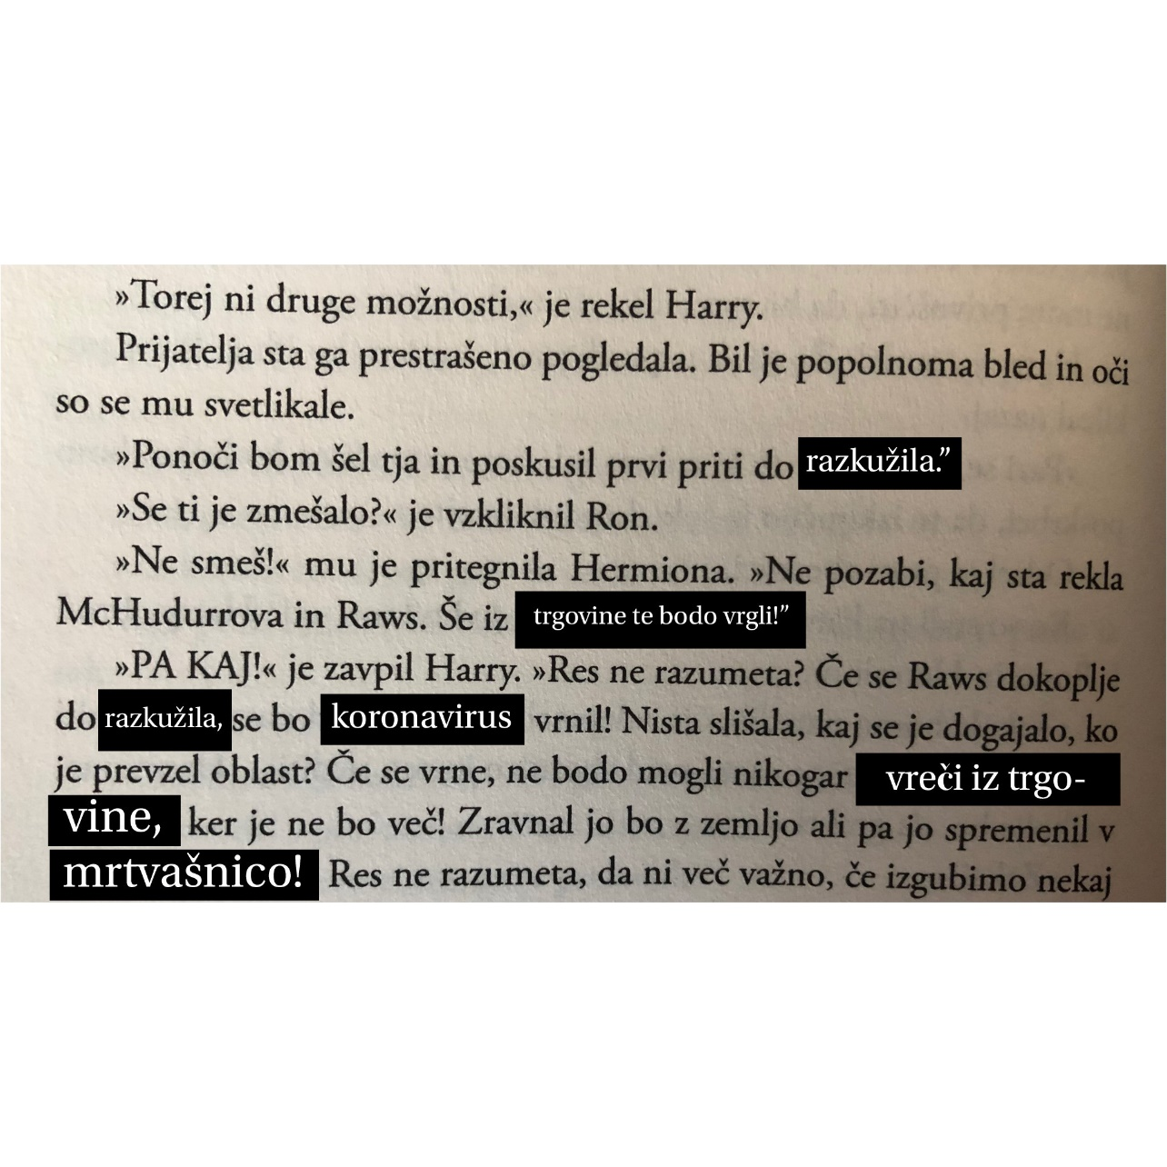

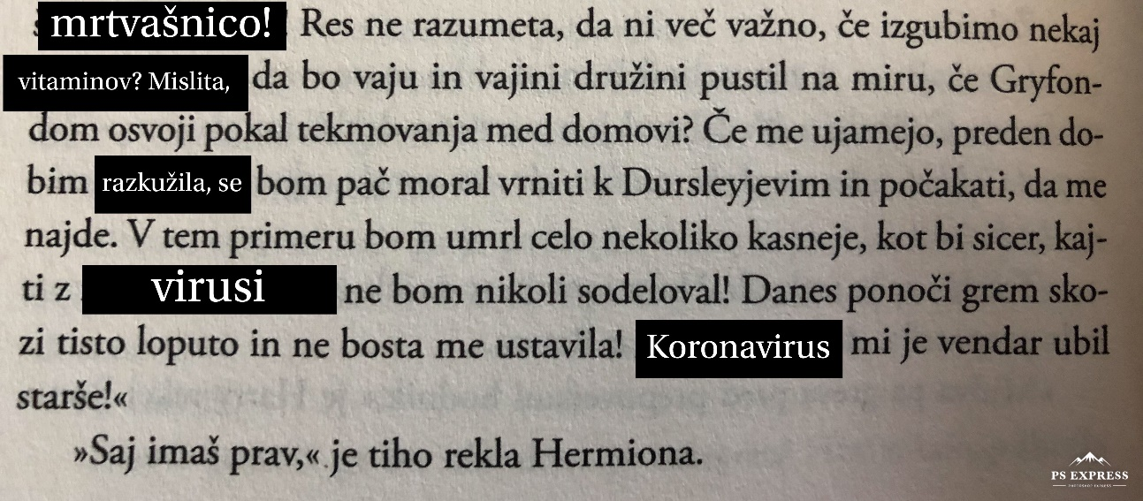
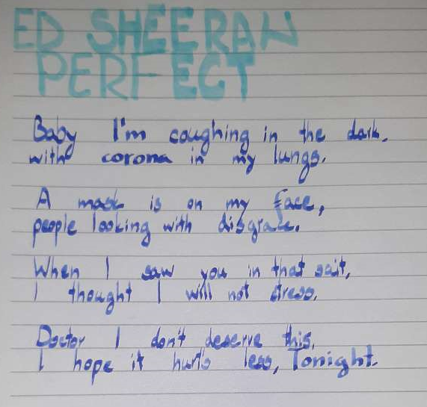
Aljaž Šparovec

Aini Neković

